# How to Create a Web Part Page in SharePoint 2013

# Troubleshooting - SharePoint Internet Explorer Compatibility Issues

http://blog.fpweb.net/sharepoint-internet-explorer-compatibility-issues-with-video/#.WL2TllWLQdV

fix for… basically adding http://internal.penad.wrshealth.com to the Intranet zone - but Windows Update has a fix as well.

**Sorry, something went wrong**

Cannot create a Web Part Page with the current browser. Browsers that support the creation of Web Part Pages include Microsoft Internet Explorer 7.0 or later, Mozilla Firefox 3.0 or later, and Apple Safari 3.0 or later.

## Tutorial

http://community.bamboosolutions.com/blogs/sharepoint-2013/archive/2012/11/05/how-to-create-a-web-part-page-in-sharepoint-2013.aspx

SharePoint 2013 adds many new features, including improvements to Lists, Sites, and Pages, as well as a variety of changes pertaining to user interface and locations. In some cases, these changes can cause difficulties in using your sites.  In this article, we will take a look at how to create a Web Part Page in SharePoint 2013. As you know, the Web Part Page is used for adding many Web Parts to a site following the structure on a page. This walkthrough shows you how to create a Web Part Page in SharePoint 2013.

First let's talk about the user interface involved in the process.  In SharePoint 2010, it's easy to see in Site Settings, but in SharePoint 2013, we need to go through a few steps.

[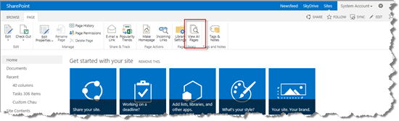](http://community.bamboosolutions.com/cfs-file.ashx/__key/CommunityServer.Blogs.Components.WeblogFiles/sharepoint-2013/wp1.png)

* On your site, go to the **PAGE** tab in the Ribbon and select the **View All Pages** menu.

* Select the **FILES** tab, expand the **New Document** drop-down list, and click on the **Web**  
  **Part Page**menu:

[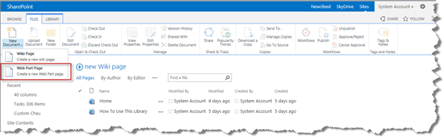](http://community.bamboosolutions.com/cfs-file.ashx/__key/CommunityServer.Blogs.Components.WeblogFiles/sharepoint-2013/wp2.png)

* Input **Name**, select **Layout** and **Save Location**, then click the **Create** button:

[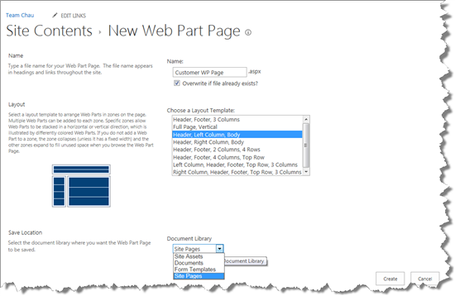](http://community.bamboosolutions.com/cfs-file.ashx/__key/CommunityServer.Blogs.Components.WeblogFiles/sharepoint-2013/wp3.png)

At this point, you will be taken to your new Web Part page:

[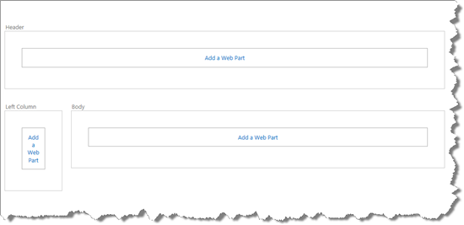](http://community.bamboosolutions.com/cfs-file.ashx/__key/CommunityServer.Blogs.Components.WeblogFiles/sharepoint-2013/wp4.png)

Enjoy!